**Experiment No.3a**

**Title**: Factorial using Recursion in C++

**Problem Statement:** Write a C++ program to calculate factorial of a given number using Recursion.

**Algorithm:**

**Step 1** -Start

**Step 2 –**Read number n

**Step 3 –**Call factorial(n)

**Step 4 –**Print factorial f

**Step 5 –**Stop

**Factorial(n)**

**Step 1** -If n==0 then return 1

**Step 2 –**Else

f=n*factorial(n-1)

**Step 3 –**Return f

**Code:**

#include<iostream>

using namespace std;

int factorial(int n)

{

int f;

if(n==0)

return 1;

else

f=n*factorial(n-1);

return f;

}

int main()

{

int num;

cout<<"Enter the number ";

cin>>num;

cout<<"The factorial of number is:"<<factorial(num)<<endl;

return 0;

}

**Results:**

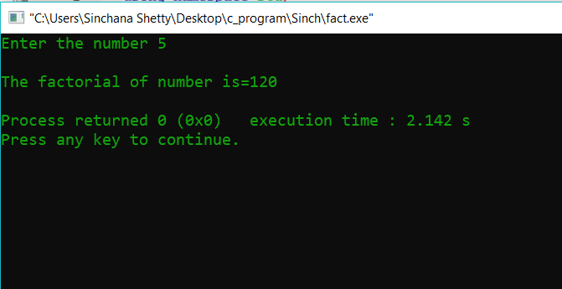

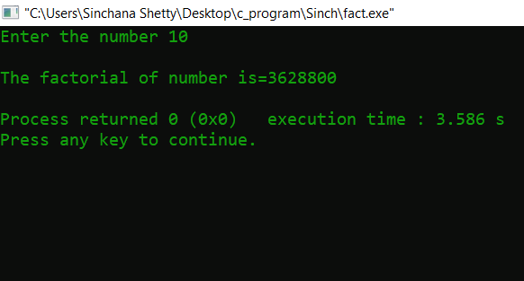

**Analysis(Limitations):**

In this code we have integer limit as 20, crossing the integer limit will result in negative values . Hence the code is restricted to calculate the factorial up till certain integer only.